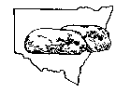SHOWING PET GUINEA PIGS

At NSW Cavy Club shows, pet guinea pigs (cavies) need to be entered on the official show form before the show, just as purebred ones are. This is Class no. 53 (Members’ Pets) on the Show Schedule which you will have received as part of your membership pack.

At Capital Country Cavy Club shows, pet guinea pigs may be entered on the day.

As a new member, you are also entitled to enter the Novice Classes in the first year of your membership. These classes allow you to learn how to prepare and present your cavy for showing.. This is Class no. 52 on the schedule.

Pet guinea pigs are usually judged on temperament, friendliness, ease of handling, cleanliness and condition. In addition there are novelty classes such as fastest eater, fancy dress, and so on.

It is a good idea to bathe your cavy a few days before the show using a small-animal shampoo to freshen him/her up. If he is an adult boar, you will need to clean his grease gland (just above where his tail would be if he had one) with a soft brush and something like tea-tree oil. Rinse thoroughly. His or her claws should also be clipped. Just remove the tips.

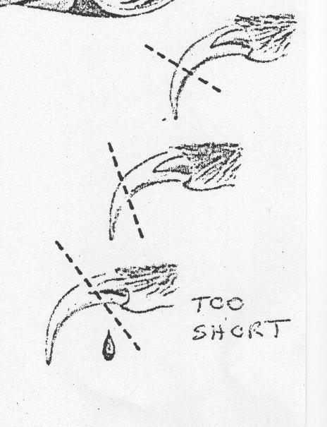
It is advisable not to feed carrot, beetroot or other staining vegetables to your cavy before a show, especially if s/he is white or a light colour. An orange or red mouth is not a good look.

The guinea pig(s) should be taken to the show in a secure carry cage such as a cat cage, preferably with something to snuggle into like a towel. Remember it will be a new experience with lots of noise and strange people rushing about so s/he will need to feel secure.

When you arrive, you need to go to the entries clerk, pay your entry fee and collect your entry form which will have numbered stickers. These are the ear tags which are attached to the left ear. This number is used to identify your cavy as in calling it to the judging table.

You then find a seat in the hall and listen for your cavy’s number to be called to the Pet Classes (and/or Novice Classes if you have also entered them).. You then take him/her up and place him/her on the table. Many people buy the show boards available through the club and place the cavy on the board then the board on the table. This helps protect him/her from picking up parasites and other nasties which can happen. The judge (the person in the white coat behind the table) will look at your cavy, pick him up and examine him. The judge may ask you a question about him or offer advice or make a comment – judges are friendly people. However, you should not talk at the table unless the judge speaks to you.

Some halls don’t have many tables though chairs are usually in good supply, so you might want to bring your own table (a folding card table will do) to rest your cavy’s cage on.

If you have any questions about showing cavies or cavies in general (health, care, feeding, etc.) you are most welcome to ask either the judge (once judging is complete), club committee members or other exhibitors. Everyone is there to help.

Castle Hill shows do not have a canteen though there are fast food outlets nearby. Coffee and tea (and cake) are usually available for a small charge, however. Capital Country Cavy Club shows have a full canteen where you can get hot food.

